EXPERIMENT-5
NAME:Rohith Nikethan p ROLLNO:240701437

User Interface Design of Shoe Shopping Application
- Aim
To design and analyze the user interface flow of a shoe shopping mobile application, starting from the home page and ending at the checkout process.
- Objective
To understand the user navigation in an e-commerce mobile interface.
To design a simple and attractive shoe shopping user interface.
To analyze the complete purchase process from product browsing to order placement.
- Tools Used
Figma or any UI design software
Flowchart design tool such as Draw.io or Lucidchart
Web technologies such as HTML and CSS for interface understanding
- Description of the Experiment
In this experiment, a mobile shoe shopping interface was designed to demonstrate how a user interacts with an e-commerce application.
The application contains multiple screens that guide the user through the purchasing process. The interface begins with a login or signup page, after which the user can browse available shoes. Products from brands such as Nike, Adidas, and Converse are displayed with images and prices.
When the user selects a shoe, the product details page displays information such as product name, price, and available sizes. The user can then add the item to the shopping bag.
The shopping bag page shows the selected product, quantity, shipping information, and a checkout button. After reviewing the cart, the user enters shipping details and selects a payment method to confirm the order.
This interface ensures a smooth user experience with clear navigation and minimal steps to complete a purchase.

5. Frame 1
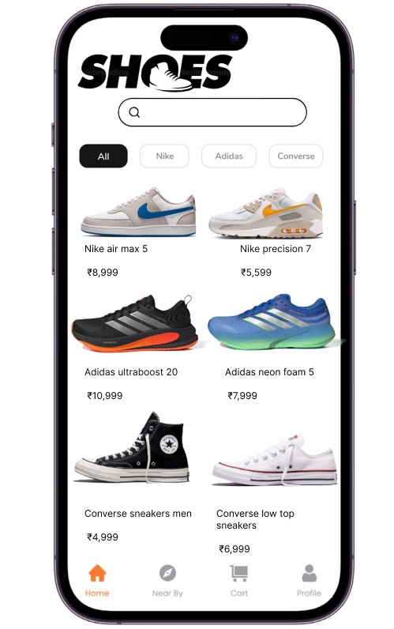

5.1 Home Page
The home page is the main screen where users can browse available shoes. It includes the brand logo, a search bar, and category filters such as Nike, Adidas, and Converse. The screen displays different shoe products with images and prices. At the bottom, a navigation bar provides quick access to Home, Nearby, Cart, and Profile sections. This screen helps users easily explore different products.
5.2 Product Details Page

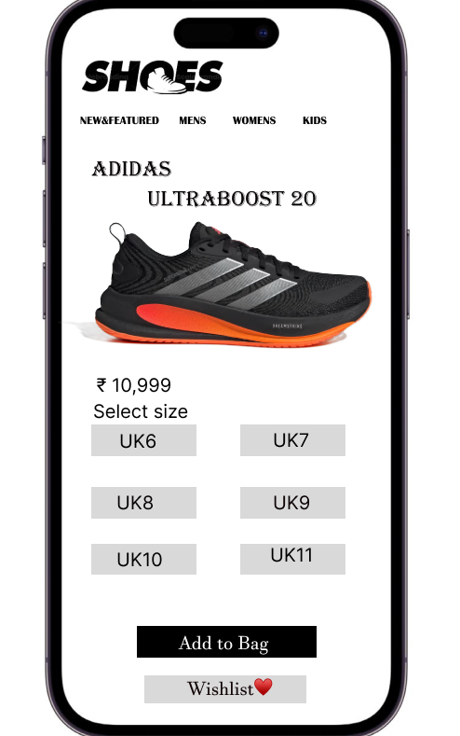

When a user selects a shoe from the home page, the product details page appears. This screen shows the product name, product image, price, and available shoe sizes. The user can choose a size and then click the add to bag button. There is also a wishlist option that allows users to save the product for later.
5.3 Shopping Bag Page
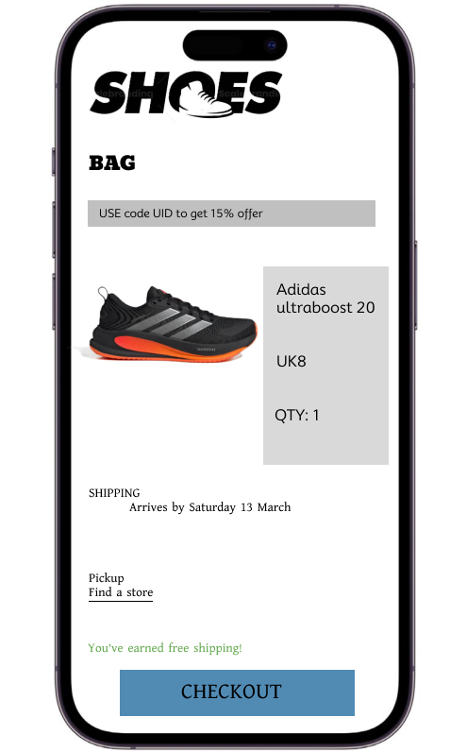
The shopping bag page shows the items selected by the user. It displays the product image, product name, selected size, and quantity. The page also provides a promo code option and shipping information. At the bottom of the screen there is a checkout button which allows the user to continue to the payment process.
6. Flowchart Explanation
The flowchart represents the complete process of purchasing shoes in the application. The process starts when the user opens the application and logs in or signs up. The system verifies whether the login information is correct. If the login details are incorrect, the user is asked to reset the password. If the login details are correct, the user can browse different shoes available in the application.
The user selects a product and chooses the appropriate size or color. The selected item is then added to the cart. The user reviews the cart and proceeds to checkout. After that the user enters shipping details and selects a payment method. Once the payment is confirmed, the order is placed successfully.
7.Flowchart Process
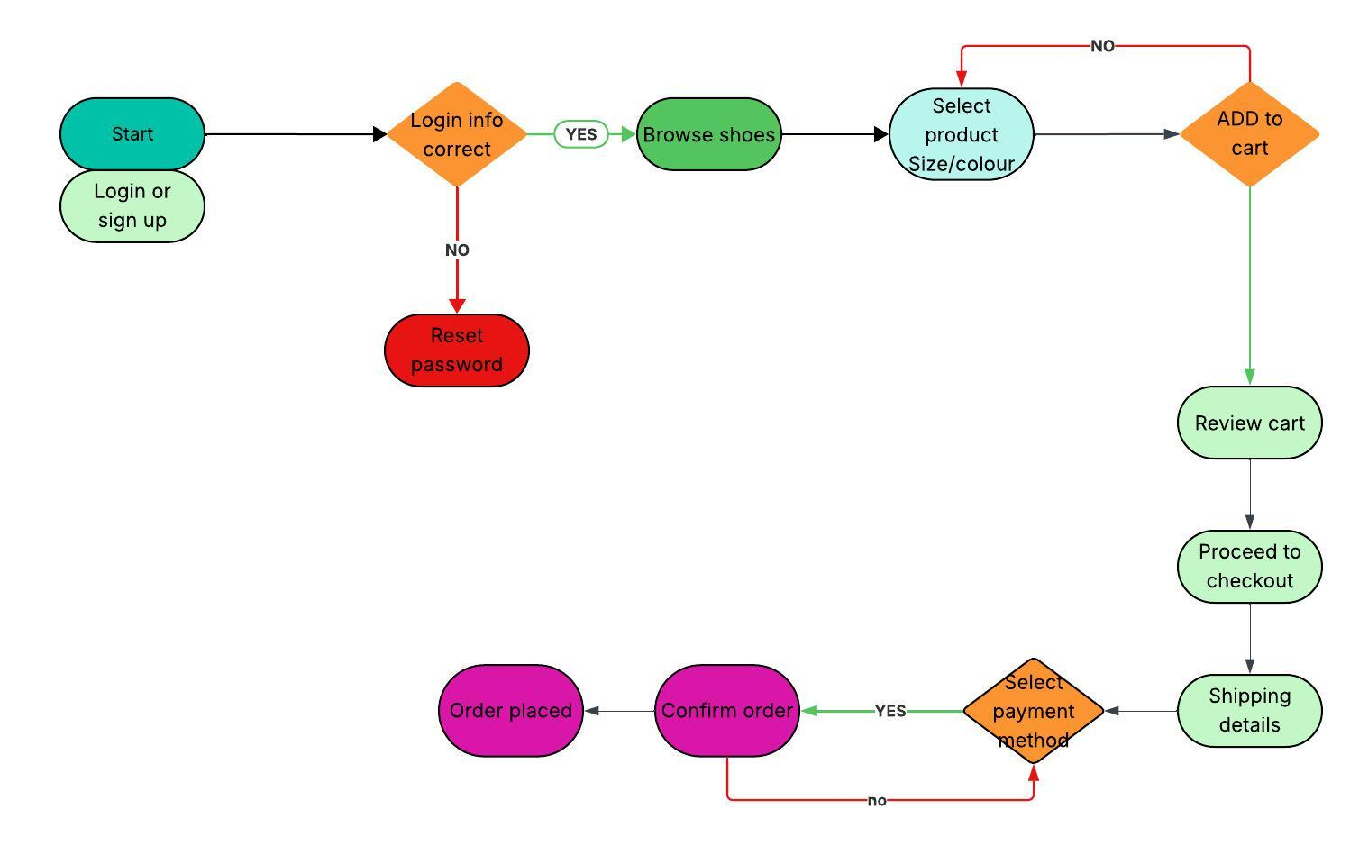
Start
Login or Sign Up
Login Information Correct
If No, Reset Password
If Yes, Browse Shoes
Select Product
Choose Size or Colour
Add to Cart
Review Cart
Proceed to Checkout
Enter Shipping Details
Select Payment Method
Confirm Order
Order Placed
End
Result: The experiment successfully demonstrates the design and flow of a shoe shopping mobile application user interface. The system provides a clear and user friendly interface that allows users to browse products, add them to the cart, and complete purchases easily.

Prototype Link:
https://www.figma.com/proto/KT2GECU98EmY6AfSspb6Gg/Untitled?node-id=0-1&t=PTj6gfyrYSlPXeZC-1

